***PHASE VELOCITY AND GROUP VELOCITY:***

**Phase Velocity ( vphase):**

Phase velocity is the velocity of the individual waves. The velocity with which each phase in a wave moves is called the phase velocity.

If we consider a point to be marked on a travelling wave, then that point represents a particular phase of the wave, and the velocity with which it is transported owing to the motion of the wave is called Phase velocity.

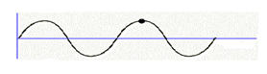

Phase velocity is given by

v**phase**= 

Where ω is the angular frequency and k is the wave number.

**Group Velocity (vgroup):**

When a group of two or more waves of different wavelengths and different velocities are superimposed on each other, the amplitude of the resultant wave is varied, which forms a wave group or wave packet. The velocity with which the envelope enclosing the wave packet is transported is called the group velocity.

In other words the velocity with which the energy in the wave group is transmitted is called group velocity. Group Velocity is represented by

**vgroup** = 

where dω is the change in angular frequency dk is the change in wave number.

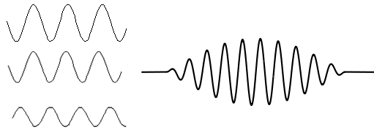

**Individual waves Wave packet**